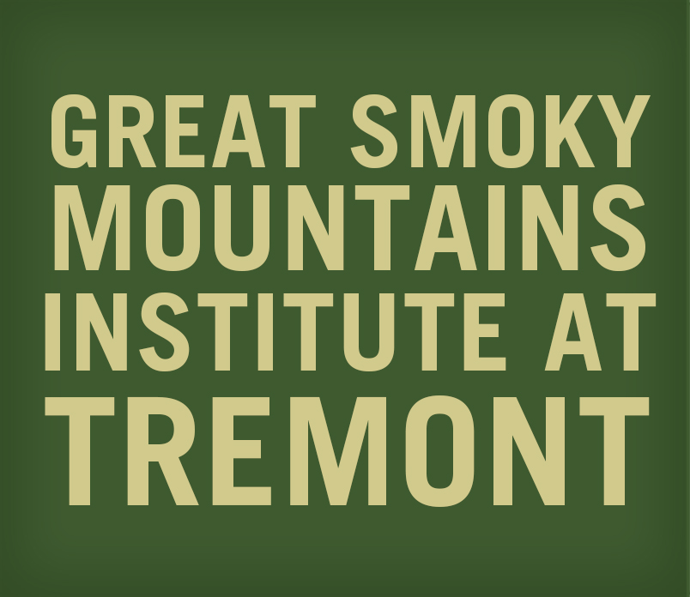

Dear Friends,

Welcome to the Southern Appalachian Naturalist Certification Program: Interpretation and
Naturalist Skills weekend! We hope this is one of many weekends we will spend together as we seek to become better naturalists. The Great Smoky Mountains are ready and waiting for your arrival.

We will focus on two areas of study this weekend. The majority of our time will be spent learning methods of interpretation. Interpretation is a key skill (and art) necessary for sharing the world with others and passing on essential information in a provocative manner. Our second area of study will be developing naturalist skills. This includes field journaling, record keeping, and awareness of the naturalist tradition. We would like to expose you to the rich history of this field of study and excite you about the journey ahead.

Instructors:
Your primary instructor for this course will be Caleb Carlton, Tremont’s Manager for Innovation and Assessment. John DiDiego, Tremont’s Education Director, will be teaching the Naturalist Skills course on Sunday afternoon. You can learn more about our staff here.

Arrival and Departure:
Plan to arrive at Tremont on Friday, February 16th between 3:00 and 5:00 PM, giving you an opportunity to move into the dorm and meet other participants before our 6:00 PM dinner. Check-In will take place in the Gift Shop, located in our office building, the first structure to appear on your left after crossing the bridge onto Tremont’s campus. The course will finish at 4:00 PM on Sunday, the 18th. For directions, use the destination: 9275 Tremont Road, Townsend, TN 37882.

Weather – Being Prepared:
February sees an average daily high of 54° F, and low of 28° F. We may be outdoors before breakfast on Saturday morning, so please bring warm layers and winter outerwear. You will be outdoors for periods of time, so it is suggested that you bring a small backpack to be hands-free, and a water bottle to stay hydrated while out on the trail. The Smokies are a very wet and humid climate; you should expect that it will rain at some point during your stay here.

Additional Logistics:
Along with your linens and toiletries, you may want to bring a mattress pad to ease the firm mattress, and a bedside light or headlamp if you are a late-night reader. You may want to consider bringing some additional items with you for this weekend such as binoculars, notepad and pencil, field guides, and camera. Note – we do provide wireless internet access in the Activity Center, though we invite you to unplug for the weekend.

Other Important Documents:
- Tentative schedule

Pre-course Homework:
Get ready! You have registered for an intense weekend during which we will cover material and skills that most people receive in a semester-long class. If you think this sounds ambitious, you are right!

Please watch these videos in advance of the course:
- Please watch at least 3 “Nature is Speaking” videos
- Ralph Waldo Emerson and the Beauty of the Everyday
- Mindfulness and Happiness

And, please read this document:
- The National Park Service’s Foundations of Interpretation

During the weekend we will also be offering you a 15% discount in our bookstore.

I hope that this information is helpful to you in planning for your upcoming visit to Tremont. If you have further questions, please feel free to call or email.

Sincerely,

Caleb Carlton, Manager for Innovation and Assessment (caleb@gsmit.org)
John DiDiego, Education Director (john@gsmit.org)

GREAT SMOKY MOUNTAINS INSTITUTE AT TREMONT
9275 Tremont Road, Townsend, TN 37882
Phone: 865-448-6709 ~ Fax: 865-448-9250
www.gsmit.org ~ mail@gsmit.org

