Aquatic Salamander Monitoring Procedures
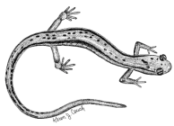

Before you pick up the Pauley bag (a.k.a. salamander hotel):
- Find your first Pauley bag (they are made out of plastic mesh and have bright orange flagging and/or a metallic tag marking them).
- Record the number on the flagging or tag (0 to 21).
- Record the % it is submerged or underwater.
- If there is a Pauley bag missing, or if a bag has few or no leaves in it, write down the bag’s number and make note of this in the notes section.
  - For Notes, record a number (starting at 1 for the first note on the sheet) on the front, and write your note on the back, labeled with the appropriate number.
- Fill one tub a quarter to halfway full with water. If the stream is shallow, you can use Ziploc bags to gather water into the tub.

Now you are ready to pick up the Pauley bag:
- Put the Pauley bag into the tub with water quickly and look under the bag to see if any salamanders are there.
- If salamanders are under or within one foot of the bag, then catch them in Ziplocs!
- Agitate (massage vigorously with your fingers) the bag in the water. You do not need to empty the leaves out. Set the Pauley bag aside.
- Pour the water in the tub through a strainer into another tub.
- Look in the strainer for any large salamanders.
- Look carefully in the tub for any smaller salamanders.

If you have salamanders:
- Catch salamanders in Ziplocs. – See the reverse side of this sheet for diagrams.
- Put sealed Ziplocs into cool water until you are ready to take data on the salamander.
- Determine if the salamander is a larva or adult (larva have gills).
- Identify the salamander to species (if possible) by using the dichotomous key. Record your identification confidence level. Record notes on characteristics you used to identify the salamander in the Notes section on the back of the datasheet.
- Measure and record the snout-vent length and total length in mm.
- Weigh the salamander and Ziploc using the spring scale and record. (Larva that are small do not need to be weighed.)
- Once the salamander is processed, you can let it go near the bag you found it in.
- Weigh the Ziploc bag. Subtract the Ziploc mass from the salamander and bag mass to get the salamander’s actual mass.

Even if you don’t have salamanders do these things:
- Record any other animals that are present in the comments section (i.e. snails, crayfish, macro-invertebrates).
- Make sure to put the Pauley bag back where you found it and re-stuff it thoroughly with leaves (it should be bulging with leaves)!
- Move on to the next Pauley bag and start at procedure #1 again.

How to Process Salamanders:

Step 1: Catch the salamander in a Ziploc bag and zip the bag shut. Attach the spring scale to the bag and hold the scale by the loop at the top. Read the mass of the bag with the salamander inside.
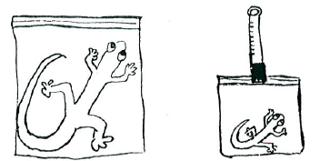

Step 2: Gently try to straighten the salamander inside the bag to get an accurate measurement of its length. Using the ruler, measure how long the salamander is, both from the tip of its nose to the tip of its tail and from the tip of its nose to its vent (or just behind the rear legs, close to the tail). Be sure to record these measurements in millimeters (mm).
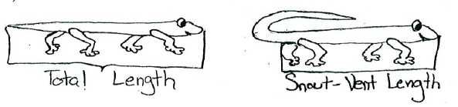

Step 3: Use the dichotomous key to identify the salamander while it is still in the bag.

Step 4: Release the salamander carefully. Remember to set it beside the leaf litter bag, not underneath it.

Step 5: Using the spring scale once again, weigh the empty bag. Subtract this number from the weight of the bag and salamander combined (from Step 1) to get the mass of the salamander.
